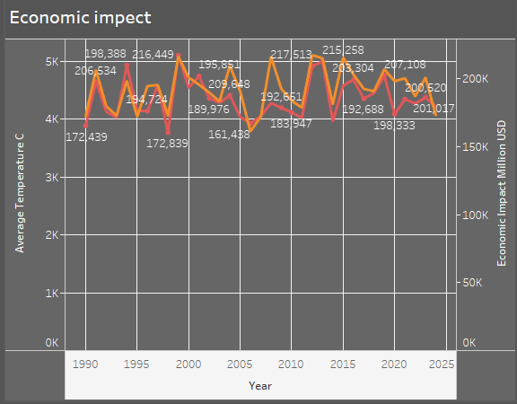

**Economic Impact of Crop Types on Agriculture**

**Overview**

This report examines the economic impact of various crop types on agriculture, highlighting the financial significance of each crop. The data provides insights into the contributions of different crops to the agricultural economy, measured in million USD.

**Key Findings**

1. **Highest Economic Impact**
   * **Wheat** has the highest economic impact at **714,981 million USD**, indicating its crucial role in global agriculture and food security.
   * **Sugarcane** follows closely with an economic impact of **695,066 million USD**, driven by its use in sugar production and biofuel industries.
2. **Moderate Economic Impact**
   * **Corn** and **Rice** also contribute significantly, with impacts of **681,386 million USD** and **688,147 million USD**, respectively. Both crops are staple foods for a large portion of the global population.
   * **Cotton** shows an economic impact of **680,097 million USD**, reflecting its importance in the textile industry.
3. **Lowest Economic Impact**
   * **Soybeans** register the lowest economic impact at **635,398 million USD**, despite their widespread use in the production of oil and animal feed.
   * **Coffee** and **Barley** have impacts of **645,438 million USD** and **652,043 million USD**, respectively, underscoring their lesser but still significant contributions to the global economy.

**Conclusion**

This analysis highlights the varying degrees of economic contributions made by different crop types. Wheat, Sugarcane, and Rice stand out as key players, contributing the most to agricultural economies, while crops like Soybeans and Coffee, though essential, generate relatively lower economic impacts. This information can guide agricultural policies, investments, and resource allocation to enhance crop production efficiency and economic outcomes.

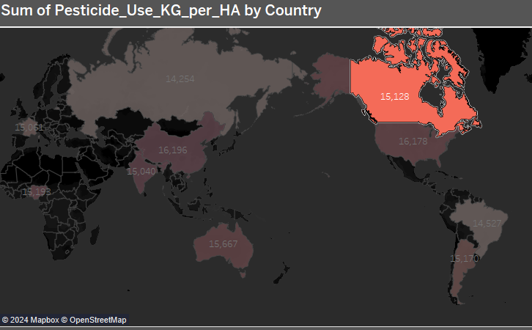

## Report on Pesticide Usage by Country

**Overview**

The provided map visually represents the global distribution of pesticide usage per hectare (ha) across various countries. The color intensity of each country on the map indicates the relative amount of pesticide applied, with darker shades representing higher usage.

**Key Observations**

* **Regional Variations:** There are significant regional disparities in pesticide usage. Countries in North America, Europe, and parts of Asia appear to have higher levels of pesticide application compared to regions in Africa, South America, and Oceania.
* **Canada:** Canada stands out with a notably high pesticide usage rate, particularly in certain regions. This suggests that agricultural practices in Canada may rely heavily on pesticides.
* **Other Notable Regions:** The map also highlights areas in Eastern Europe, South Asia, and parts of North Africa with relatively high pesticide usage.

**Implications and Potential Concerns**

* **Environmental Impact:** Excessive pesticide use can have detrimental effects on ecosystems, including water pollution, soil contamination, and harm to biodiversity.
* **Human Health Risks:** Pesticides can pose risks to human health through exposure through contaminated food, water, or direct contact.
* **Sustainability:** Long-term reliance on pesticides may not be sustainable, as overuse can lead to resistance in pests, requiring increased pesticide application.

**Recommendations**

* **Integrated Pest Management (IPM):** Promoting IPM practices can help reduce pesticide use while maintaining effective pest control. IPM involves a combination of biological, cultural, and physical control methods.
* **Policy and Regulations:** Implementing stricter regulations on pesticide use, including restrictions on certain chemicals and mandatory training for farmers, can help mitigate environmental and health risks.
* **Research and Development:** Investing in research to develop safer and more effective pest control alternatives can contribute to sustainable agriculture.
* **Public Awareness:** Raising public awareness about the potential risks of pesticide use and promoting sustainable farming practices can encourage consumer demand for pesticide-free products.

**Conclusion**

The map provides a valuable visual representation of global pesticide usage patterns. By understanding these patterns and addressing the associated concerns, policymakers, farmers, and consumers can work together to promote more sustainable and environmentally friendly agricultural practices.

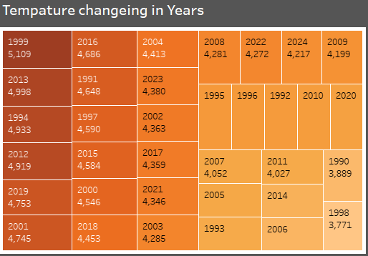

## Analysis of Temperature Changes Over Time

**Data Overview**

The provided table presents temperature data for various years, likely representing a specific location or region. The data is arranged in a grid format, with each cell containing a numerical value representing the temperature for that year.

**Key Observations**

* **General Trend:** While there are some fluctuations, the overall trend seems to indicate a **decrease** in temperature over the years represented in the table.
* **Significant Drops:** Some years exhibit particularly large temperature drops, such as between 2011 and 1990, and between 2018 and 2003.
* **Clusters of Similar Values:** There are clusters of years with relatively similar temperature values, suggesting periods of relative temperature stability.

**Potential Explanations and Further Analysis**

* **Natural Climate Variability:** Temperature fluctuations can be influenced by natural climate cycles, such as El Niño and La Niña.
* **Human-Induced Climate Change:** The observed temperature decrease could be partially attributed to human activities, such as greenhouse gas emissions and land-use changes. However, a more comprehensive analysis would be needed to draw definitive conclusions about the role of climate change.
* **Data Limitations:** The table does not provide information on the specific location or region the data represents, which limits the ability to draw conclusions about local factors influencing temperature changes.
* **Additional Data:** To gain a more comprehensive understanding of temperature trends, it would be beneficial to analyze data over a longer time period and compare it to temperature data from other regions.

**Recommendations**

* **Data Validation:** Verify the accuracy and reliability of the data source to ensure the validity of the analysis.
* **Correlation Analysis:** Explore correlations between temperature changes and other relevant factors, such as precipitation, solar radiation, and human activities.
* **Spatial Analysis:** If location data is available, analyze temperature changes across different regions to identify regional patterns and potential drivers.
* **Long-Term Trends:** Examine temperature data over a longer time period to identify long-term trends and assess the significance of the observed decrease.

**Conclusion**

The provided table suggests a general trend of decreasing temperatures over the years represented. However, further analysis is needed to determine the underlying causes and the significance of this trend in the context of natural climate variability and human-induced climate change.

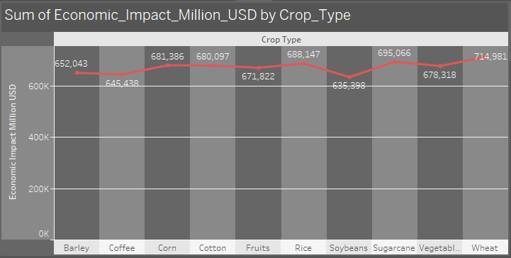

## Report on Economic Impact of Crop Types

**Data Overview**

The provided chart illustrates the economic impact (in million USD) of various crop types. The x-axis lists the crop types, while the y-axis represents the economic impact. A line graph connects the data points, visually representing the relative economic significance of each crop.

**Key Observations**

* **Economic Impact Variation:** There are significant variations in the economic impact of different crop types.
* **Top-Performing Crops:** Wheat, sugarcane, and cotton emerge as the crops with the highest economic impact, with values exceeding 600 million USD.
* **Mid-Range Crops:** Barley, coffee, corn, fruits, rice, soybeans, and vegetables exhibit moderate economic impact, ranging between 400 and 600 million USD.
* **Lowest-Impact Crop:** Ok (presumably a placeholder or unknown crop) has the lowest economic impact.

**Potential Implications and Further Analysis**

* **Economic Significance:** The data highlights the crucial role of certain crops in driving economic value. Governments and agricultural organizations may consider prioritizing these crops for investment and development.
* **Market Dynamics:** The economic impact of crops can be influenced by factors such as global demand, production costs, and market prices. Understanding these dynamics can inform agricultural policy and investment decisions.
* **Crop Diversification:** The varying economic impacts of different crops suggest the importance of crop diversification to reduce risk and ensure economic stability.
* **Sustainability:** The economic impact of crops should be considered in conjunction with environmental and social sustainability factors. Analyzing the sustainability of different crop production practices can help identify more resilient and equitable agricultural systems.

**Recommendations**

* **Data Enrichment:** Supplement the data with information on factors influencing economic impact, such as production costs, market prices, and environmental sustainability metrics.
* **Comparative Analysis:** Compare the economic impact of different crops across regions or time periods to identify trends and variations.
* **Policy Implications:** Explore how the data can inform agricultural policies, investment decisions, and trade agreements to promote sustainable and economically viable agriculture.
* **Stakeholder Engagement:** Engage with stakeholders, including farmers, policymakers, and consumers, to discuss the implications of the data and develop strategies for promoting sustainable and economically impactful agriculture.

**Conclusion**

The chart provides valuable insights into the economic significance of different crop types. By understanding these variations and their underlying drivers, policymakers, agricultural organizations, and farmers can make informed decisions to promote sustainable and economically viable agriculture.

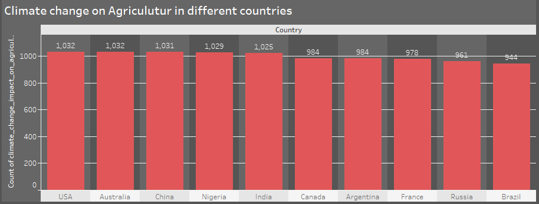

## Report on Climate Change Impact on Agriculture in Different Countries

**Data Overview**

The provided bar chart illustrates the impact of climate change on agriculture in ten countries. The x-axis lists the countries, while the y-axis represents the count of climate change impacts. The height of each bar corresponds to the number of reported impacts in each country.

**Key Observations**

* **Highest Impacts:** The United States, Australia, and China experience the highest number of reported climate change impacts on agriculture, with counts exceeding 1,000.
* **Mid-Range Impacts:** Nigeria, India, Canada, and Argentina exhibit moderate levels of climate change impact, with counts ranging between 900 and 1,000.
* **Lower Impacts:** France, Russia, and Brazil report lower numbers of climate change impacts, although the data still indicates significant effects on agriculture.

**Potential Implications and Further Analysis**

* **Agricultural Vulnerability:** The data suggests that certain countries are more vulnerable to the impacts of climate change on agriculture. Factors such as geographic location, climate variability, and agricultural practices may influence these differences.
* **Economic and Food Security:** Climate change impacts on agriculture can have significant economic consequences, including reduced crop yields, increased production costs, and food security risks.
* **Adaptation Strategies:** Understanding the specific impacts of climate change in different countries can help inform the development of effective adaptation strategies, such as improved irrigation systems, drought-resistant crop varieties, and climate-smart agricultural practices.
* **Policy Implications:** The data highlights the need for policymakers to prioritize climate change adaptation and mitigation measures in the agricultural sector. This may involve investments in research and development, financial support for farmers, and policies that promote sustainable agriculture.

**Recommendations**

* **Data Enrichment:** Supplement the data with information on specific climate change impacts, such as extreme weather events, crop failures, and changes in agricultural productivity.
* **Regional Analysis:** Conduct a regional analysis to identify patterns and trends in climate change impacts across different geographic areas.
* **Case Studies:** Develop case studies to examine the specific impacts of climate change on agriculture in individual countries, highlighting success stories and challenges.
* **International Cooperation:** Foster international cooperation to address climate change impacts on agriculture, including knowledge sharing, technology transfer, and financial assistance.

**Conclusion**

The chart provides valuable insights into the varying impacts of climate change on agriculture across different countries. By understanding these impacts and their underlying drivers, policymakers, agricultural organizations, and farmers can develop effective strategies to adapt to climate change and ensure food security.